REPORT

1. Which method seems to have the best results?

Holt’s linear trend method works best because it considers trend and seasonality. It gives better RMSE results. We can say that most of the time it is a better method for forecasting.

2. The effect of the smoothing approaches on stationarity and RMSE.

Smoothing the data helped me to find better estimations because it eliminated the effect of trend and seasonality. Random approach was also good, but it was not as good as moving average. Moving average also had some disadvantages like lagging. The data lagged so it will be hard to get real time results from this method.

3. Choosing a window size of 60 (minutes) to smooth using moving averages, would impose an artificial lag of 60 minutes on observing changes in trend. Knowing this, would you change your window size? Would your decision be different for both estimations (next 2 minutes, next day)?

I won’t change the window size for next 2 minutes, but I will change it for next day. For next day I will set the window size to 1440 because it will give a better result.

Note: 7 sets for estimating 15:57 and 15:58 = my RMSE values are in the program :)

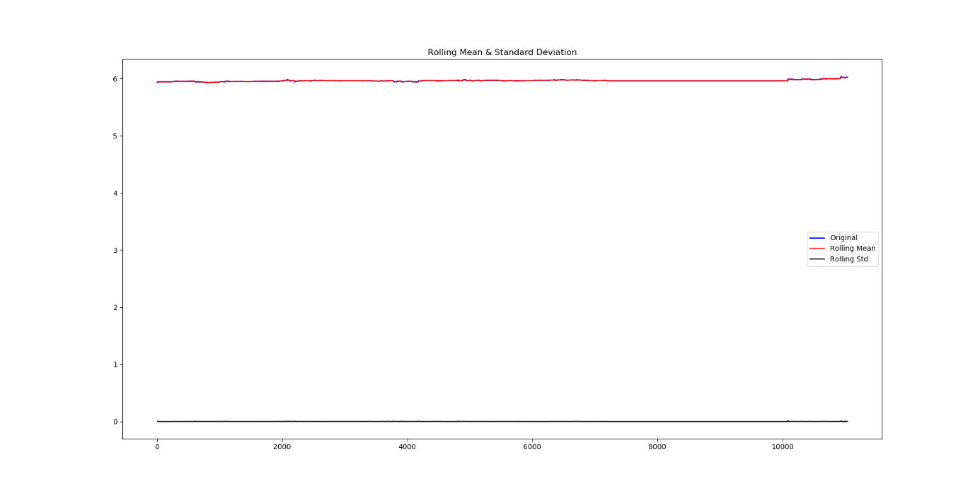

Figure_1_DataStationary

Results of Dickey-Fuller Test:

Test Statistic -1.612920

p-value 0.476443

#Lags Used 2.000000

Number of Observations Used 11036.000000

Critical Value (1%) -3.430943

Critical Value (5%) -2.861802

Critical Value (10%) -2.566909

Dollar estimation: 6.023640040905142

Estimate holt RMSE: 0.0042999999999997485

Dollar estimation: 6.023640040905142

estimate HOLT: 6.0236

actual: 6.0193

Naive estimate: 6.0193

RMSE for holt estimation: 0.0042999999999997485

RMSE for naive estimation: 0.0

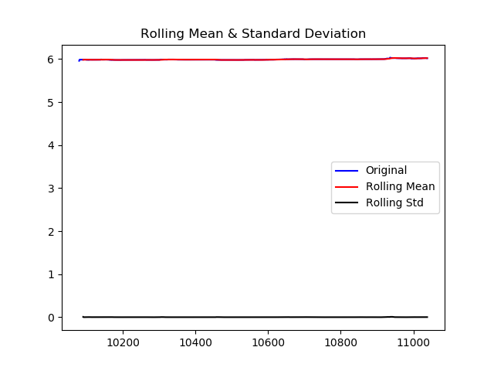

Figure_1_May6_only

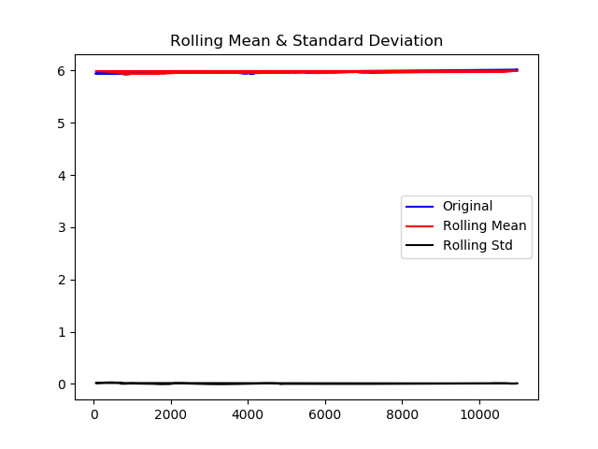

discard rows with no trading data 59 60 time data Part b

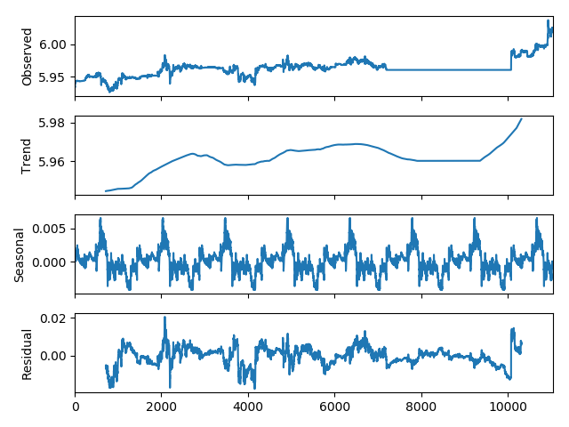

decomposed data plots

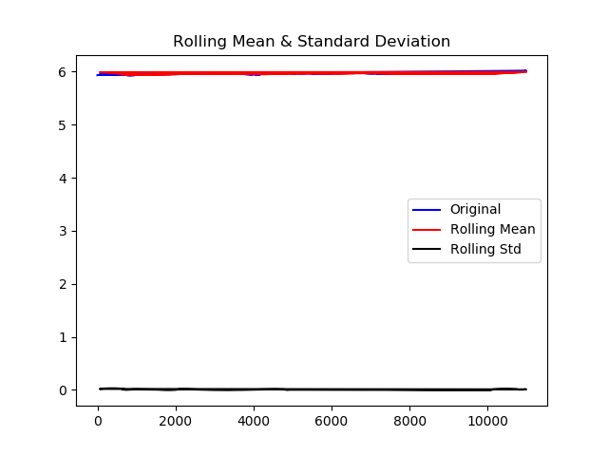

stationarity for at 59 and 00 minutes data

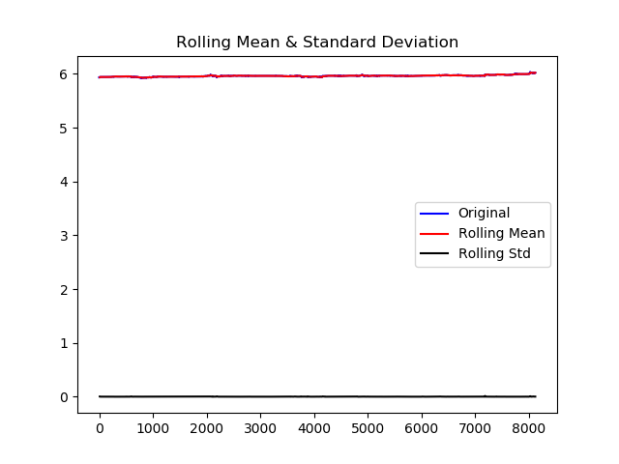

3a check stationarity (save the plots)

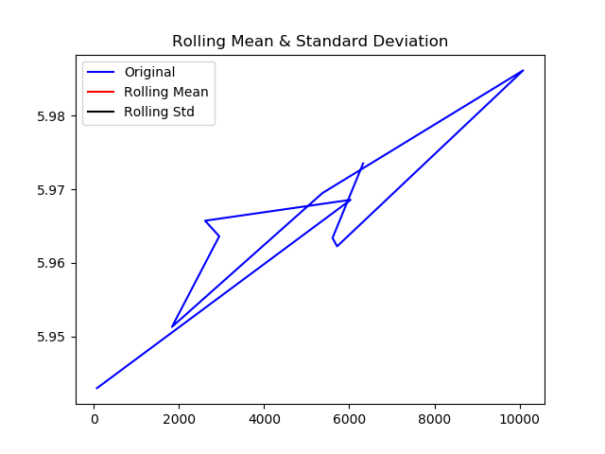

3C one random (representative) pick from each hour